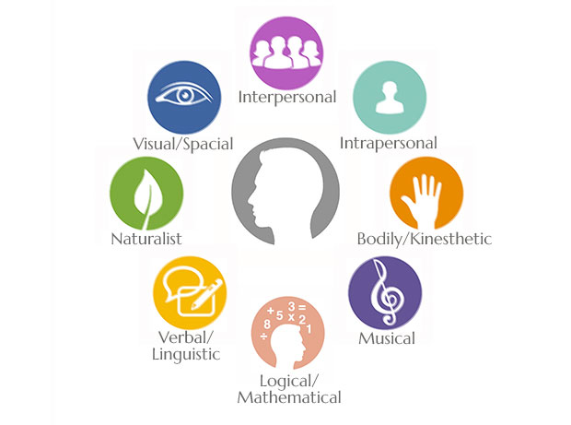
Learning Style & Multiple Intelligences Reflection
Name:
Date:

Directions: After completing at least 3 surveys, reflect upon what you have learned about yourself by answering the following questions.

- How do you prefer to learn? Use results from the learning style surveys to support your response.

- Take a look at the Learning Style Strategies handout. Based on your learning style, highlight some of the strategies that could work for you. Describe at least 2-3 of these strategies and why they would work for you.

- According to the Multiple Intelligence Inventories, what are your strengths? How can you utilize these strengths at school?

- According to the Multiple Intelligence Inventories, what are your weaknesses? How can you work on developing these areas?

