Name: _______________________________ Core: _____ Date: _______________________ Score: _____ / 20

Which Method is Best?

My System

Solving by Graphing
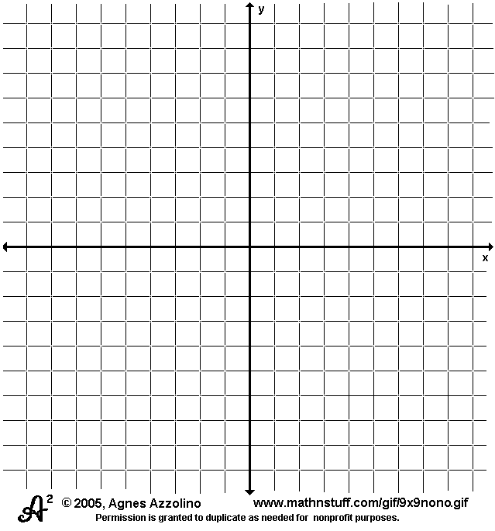

Solving by Substitution

Solving by Elimination

Analysis of Methods
________________________________________________________________________________________________________________________________________________________________________________________________________________________________________________________________________________________________________________________________________________________________________________________________________________________________________________________________________________________________________________________________________________________________________________________________________________________________________________________________________________________________________________________________________________________________

